**A POTENT ARGUMENT RENTENTION REPORT IN A ARCHETYPE DIRECTORY**

**Preface**

**TABLE OF CONTENTS**

**1. SOFTWARE DEVELOPMENT LIFE CYCLE**

**2. PLATFORM KNOWLEDGE**

**3. ABOUT PROJECT**

3.1 ABSTRACT

3.2 SCOPE OF THE PROJECT

3.3 EXISTING SYSTEM

3.3.1 DISADVANTAGES

3.4 PROPOSED SYSTEM

3.4.1 ADVANTAGES

**4. BOTTOM LINE AND FUTURE ENHANCEMENT**

**5. HARDWARE AND SOFTWARE REQUIREMENTS**

**1. SDLC (Software Development Life Cycle)**

The Software Development Life Cycle is a systematic process for building software that ensures the quality and correctness of the software built. SDLC process aims to produce high-quality software which meets customer expectations. The software development should be completed within the pre-defined time frame and cost.

**SDLC Phases**

The entire SDLC process is divided into the following stages:

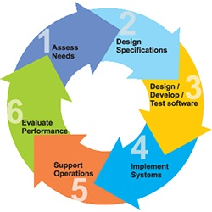

* Phase 1: Requirement collection and analysis
* Phase 2: Feasibility study
* Phase 3: Design
* Phase 4: Coding
* Phase 5: Testing
* Phase 6: Installation/Deployment
* Phase 7: Maintenance

**2. PLATFORM KNOWLEDGE**

**Introduction to java**

Java programming language was originally developed by Sun Microsystems which was initiated by James Gosling and released in 1995 as a core component of Sun Microsystems' Java platform.Initially, the language was called “Oak” but it was renamed as “Java” in 1995.The primary motivation of this language was the need for a platform-independent language. Finally, Java is for Internet Programming where C was to System Programming.

**Java architecture**

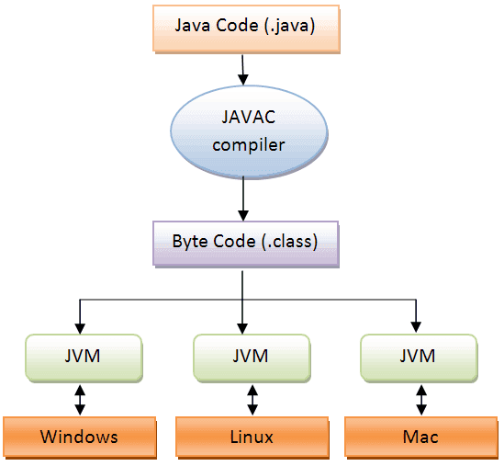Java is a high-levelObject-oriented programming language. A program written in high level language cannot be run on any machine directly. First, it needs to be translated into that particular machine language. The javac compiler does this thing, it takes java program (.java file containing source code) and translates it into machine code (referred as byte code or .class file). Java Virtual Machine (JVM) is a virtual machine that resides in the real machine (your computer) and the machine language for JVM is byte code. JVM executes the byte code generated by compiler and produce output. JVM is the one that makes java platform independent.

**A POTENT ARGUMENT RENTENTION REPORT IN A ARCHETYPE DIRECTORY**

**3. About the Project**

**3.1 Abstract**

The accumulation and sharing of the bigdata is one of the serious concerns. As the massive amount of data must be accessible in all circumstances in case of any failure or not responding of the cloud. We present a practical cloud of clouds storage mechanism which is capable of storing and distribution of big data in a secure, reliable, and efficient way by using the multiple providers of cloud service and storage repositories to accompany with the sensitive personal data. We implement some of the features that enables the accumulation and sharing big data securely. It efficiently deals with multiple storage locations, support reasonably big files, and offer controlled file sharing of the data. It efficiently deals with large files over a set of geo-dispersed storage services. For the security purpose the data stored in the cloud is in encrypted format and only the authorized clients related to the specific data will be accessible. Besides that, we developed a novel protocol to avoid write-write conflicts between clients accessing and the shared repositories.

**3.2 Scope of the Project**

The scope of the project includes the storing up of massive amount of data in a secure and reliable way. Though the data is very huge amount storing and maintaining is a big concern in the technology.And the stored data may be prone to security issues and data integrity issues as well. Because of the data is accumulated a single cloud or belonged to single cloud provider so that the replication of the data is not maintained which leads to the data loss because of storage maintained in single cloud. The stored data must be in the encrypted format as well as kept in the multiple cloud to manage the data sharing and it does not require trust on the single cloud provider. The encryption and decryption of the data is also considered conflicts in the case of bigdata. The main aim of the project is to provide a more reliable clouds sharing the big data in a secure manner.

**3.3 Existing system**

In the existing system many cloud storages do not provide the file synchronization as it is based upon the single cloud services. There is a problem for the scalable infrastructure for storing the scalable data and to maintain and manage those data. In the case of such data storage their serious concern about the security arises. Conversely, attributes like cost-effectiveness, ease of use, and (almost) infinite scalability make public cloud services natural candidates to address data storage problems. Unfortunately, many organizations are still reticent to adopt public cloud services. The sensitive and important contents must be protected from the unauthorized users to access or modify those data.

**3.3.1 Disadvantages**

* Lack of centralized cloud storage management for storing the data.
* Complex is designing a scalable storage area.
* Difficult in maintaining the large amount of increased overhead.
* Data availability is reduced in this existing system.

**3.4 Proposed system**

The proposed system uses cloud-of-clouds replication of encrypted and encoded data to avoid having any cloud service provider as a single point of failure, operating correctly even if a fraction of the providers unavailable. This system uses cloud of clouds which means, the metadata of the data will be stored and maintained on the separate cloud storage for efficient sharing. It provides a data centric design where it does not depend on a single cloud provider, data centric design. For that purpose, it uses leasing protocol to avoid the write conflicts between the data. It is a distributed file system that provides an interface to access an ecosystem of multiple cloud services and allows data transfer between clients.

**3.4.1 Advantages**

* Due to the Cloud of clouds architecture the metadata is maintained to manage the cloud stored data.
* Handles the big data in a secure and reliable way.
* Efficient Encryption scheme on every file chunk ensures the enhanced security level.
* Sharing the specific encrypted data among the dataset without disturbing to the other sets is maintained.

**4. BOTTOMLINE AND FUTURE ENHANCEMENT**

A cloud-backed file system for storing and sharing big data. Its design relies on two important principles: files metadata and data are stored in multiple clouds, without requiring trust on any of them individually, and the system is completely data centric. Our results show that this design is feasible and can be employed in real-world institutions that need to store and share large critical datasets in a controlled way.The future enhancement includes the data integrity between the multiple cloud providers and the efficient algorithm for the management i.e. storing and processing of those data. Another enhancement is the use of Byzantine-resilient datacentric algorithms for implementing storage and coordination. There are some works that propose the use of this kind of algorithms for implementing dependable systems.

**5. HARDWARE AND SOFTWARE REQUIREMENTS**

**HARDWARE REQUIREMENTS:**

* Processor : Intel (R) Pentium (R)
* Speed : 1.6 GHz and Above.
* RAM : 4 GB and Above.
* Hard Disk : 120 GB.
* Monitor : 15’’ LED SVGA
* Input Devices : Keyboard, Mouse.

**SOFTWARE REQUIREMENTS:**

* Operating system : Windows 7 / 8 / 8.1 / 10.
* Coding Language : JAVA / J2EE.
* Java Version : jdk 8.
* IDE : Eclipse Oxygen.
* Database : MySQL v5.1.
* Database Tool : HeidiSql v11.0.
* Application Server : Apache Tomcat 8.X / 9.X.